Civil war in Liberia

UNSC Resolution: | 1041
Date of adoption: | 29-Jan-1996
Operative paragraph: | 4
Demand number: | 1041,0411
Sarah-Myriam Martin-Brûlé

Wording of demand

demands that such hostile acts [recent armed attacks against personnel of ECOMOG and against civilians] cease forthwith

List of addressees of the demand

National Patriotic Front of Liberia, Government of Liberia, Central Revolutionary Council of the National Patriotic Front of Liberia, Lola Defence Force, Liberian National Conference, Liberian Peace Council, United Liberation Movement of Liberia for Democracy - Krahn, United Liberation Movement of Liberia for Democracy - Mandingo

Short-term compliance

Description of the addressee(s)’ conduct

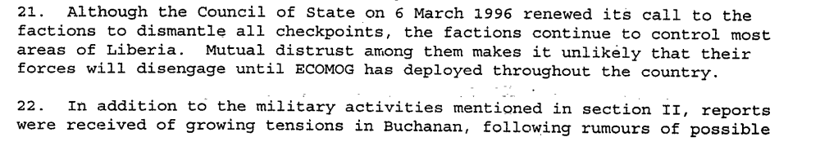
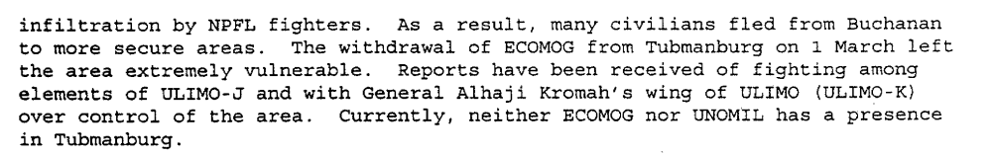
Sixteenth Progress Report of the Secretary-General on the United Nations Observer Mission in Liberia, S/1996/232, 1 April 1996.

“By a letter dated 19 April 1996, addressed to the President of the Security Council, the Secretary-General described the widespread looting and complete breakdown of law and order since the eruption of fighting in Monrovia on 6 April 1996. Given the security situation, civilian and military non-essential personnel of UNOMIL, United Nations agencies and non-governmental organizations had been relocated to neighbouring countries. Thousands of people had been displaced and were living in desperate conditions. He stressed that those developments had clearly demonstrated that ECOMOG’s “chronic” lack of manpower and logistics had seriously undermined its operational effectiveness.”
“On 21 May 1996, pursuant to resolution 1041 (1996), the Secretary-General submitted to the Council his seventeenth progress report on UNOMIL, describing developments in Liberia, and containing his recommend actions on the future role of the Observer Mission. The Secretary-General reported that renewed hostilities had continued and were seriously jeopardizing the peace process, and the security situation in Monrovia remained dangerous and unpredictable. Over the previous six weeks, faction leaders had shown wanton disrespect for the United Nations, ECOWAS and the international community, as well as disregard for the Liberian people’s desire for peace. ECOWAS had agreed on steps to resume the implementation of the Abuja Agreement, but warned the faction leaders that if they failed to implement the measures agreed upon, it would reconsider its involvement in Liberia. He underscored that the withdrawal of ECOMOG could be catastrophic, not only for the country but for the whole subregion. Moreover, should the Monitoring Group be compelled to withdraw, UNOMIL would be forced to do the same. The Secretary-General stated that UNOMIL continued to play an important role in Liberia and therefore recommended a three-month extension of its mandate, until 31 August 1996. The willingness of the faction leaders to engage in genuine negotiations would be an important factor in determining further involvement of the international community in Liberia.”
http://www.un.org/en/sc/repertoire/96-99/CHAPTER%208/African/02%20-%20Liberia.pdf

“They had reignited violence; turned Monrovia from a safe haven into a war zone; and looted the equipment of relief agencies. Notwithstanding that situation, the international community needed to remain engaged in the efforts to provide relief and to bring peace to the people of Liberia. He expressed his country’s belief that the Security Council needed to support the important initiative by the countries of the region. His delegation would support the extension of the mandate of UNOMIL, however it urged all Liberians, particularly the faction leaders, to use that time to meet the conditions ECOWAS had laid out and to offer their people the chance for peace.”
Chatper 8, ‘The Situation in Liberia’
http://www.un.org/en/sc/repertoire/96-99/CHAPTER%208/African/02%20-%20Liberia.pdf

“A number of events signalled that the first Abuja Agreement was on the road to collapse. The first was the increasing number of cease-fire violations p.88
The breakdown of security gradually escalated and culminated in the April 1996 crisis when violence erupted among warring parties.” (Alao, Mackinlay & Olonisakin 1999: 88)
Abiodun Alao, John Mackinlay, Funmi Olonisaki. 1999. Peacekeepers, Politicians and Warlords: the Liberian Peace Process. United Nations University Press.

Assessment

Short-term compliance
X No or marginal compliance (1) | Medium low compliance (2) | Medium high compliance (3) | Full or almost full compliance (4)

Considerations underlying the assessment

The unprecedented number of cease-fire violations and the April Crisis show that the demand addressees did not comply with this demand within the six months following the adoption of the resolution.

Medium-term compliance

Description of the addressee(s)’ conduct
In late 1996:
‘Despite these positive developments, the security situation in Liberia remained volatile. Outbreaks of sporadic inter-factional fighting continued, mainly between the two ULIMO factions on the one hand, while LPC continued to harbour deep suspicion against NPFL on the other.”
UNOMIL, Liberia, Background
http://www.un.org/Depts/dpko/dpko/co_mission/unomilFT.htm#DECEMBER
In 1997:
“On the military side, the situation was characterized by relative peace and stability throughout Liberia and the country was considered secure enough for elections to take place nationwide. Although a few minor incidents continued to occur in various parts of the country, ECOMOG was able to control the security situation effectively in all cases.”
UNOMIL, Liberia, Background
http://www.un.org/Depts/dpko/dpko/co_mission/unomilFT.htm#DECEMBER

Assessment

Medium-term compliance
No or marginal compliance (1) | Medium low compliance (2) | X Medium high compliance (3) | Full or almost full compliance (4)

Considerations underlying the assessment

Within the two years following the adoption of the resolution, the demand addressees had significantly ceased hostile act.

Depth of demand

Assessment

Level of depth of demand
Low depth of demand (1) | Medium depth of demand (2) | X High depth of demand (3)

Considerations underlying the assessment

In the absence of a guarantee of compliance by the other demand addressees, compliance with this demand put the survival of the demand addressees at risk.

Level of confidence about coding decisions

Level of confidence about coding decision
Extremely high | X High | Moderate

Comments to IPI (if any)

